Integrate Vision-Language Model (GOWTHAM B)
13/07/2026
Work flow:
- User uploads a PDF file.
- Server saves the file and instantly sends back a job ID (user doesn't wait).
- In the background, each page is turned into an image.
- Each page image is sent to the VLM with a question: "does this have a chart or table? if yes, give me the data as JSON."
- As each page finishes, progress is updated (e.g. "12 of 40 done").
- Frontend checks progress every few seconds and shows it to the user.
- Once all pages are done, results are saved and marked "complete."
- User fetches the final extracted data (charts/tables) using the same job ID.
- Temporary files (uploaded PDF, page images) are deleted to save space.
- If the same PDF is uploaded again, cached results are returned instantly instead of redoing the work.

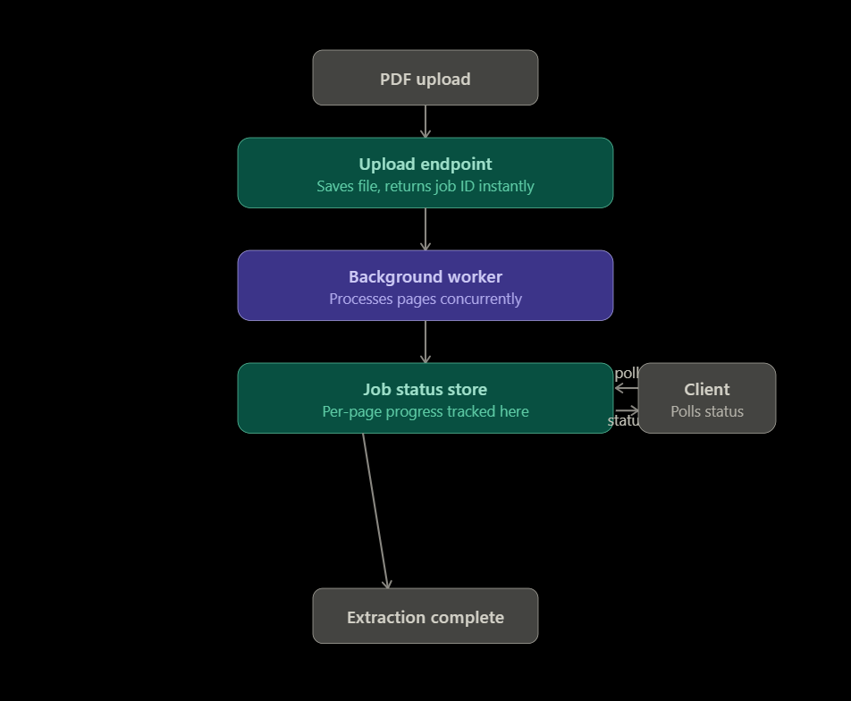
Extractor Code :
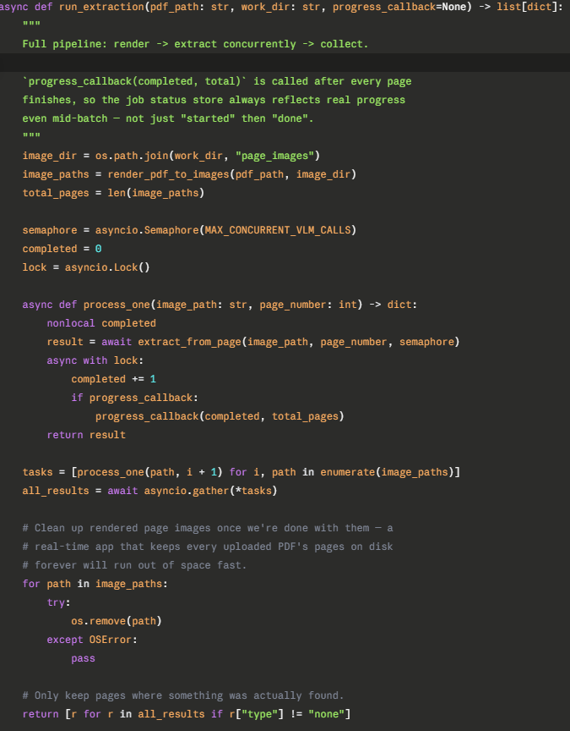
Next working with VLM..!!

